**Task Management System Testing Errors Document**

1. Change the image according to task management system and first letter of admin should be capital (Admin is enough delete 1).

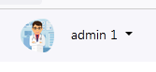

1. When create a new client so the password could not show password this option not work kindly check this.

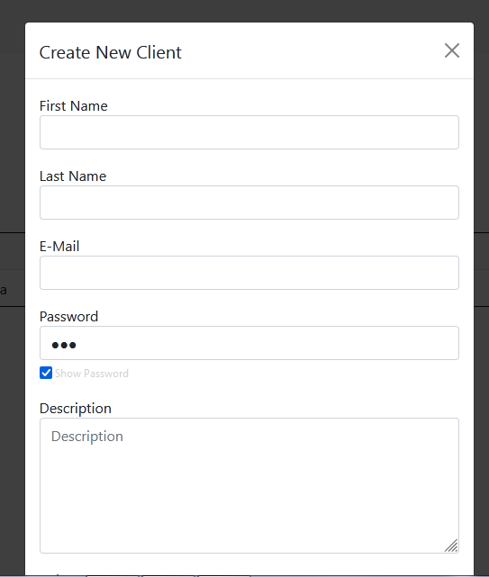

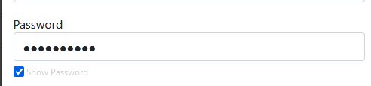

1. In comment box post link could not worked and the red bar shows that the valid URL kindly check this.

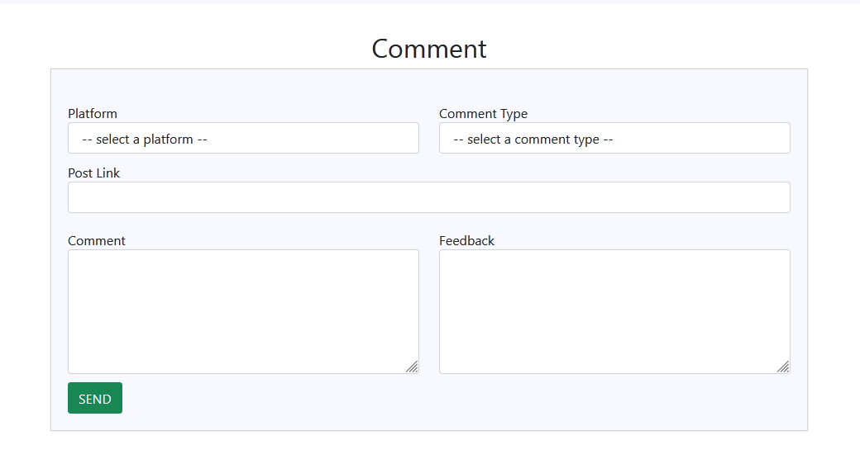

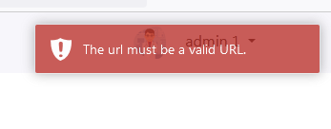

1. In create projects the word is incorrect its due date not due to date. And what is the purpose behind the auto assign check box because in my opinion this is not useful for this box.

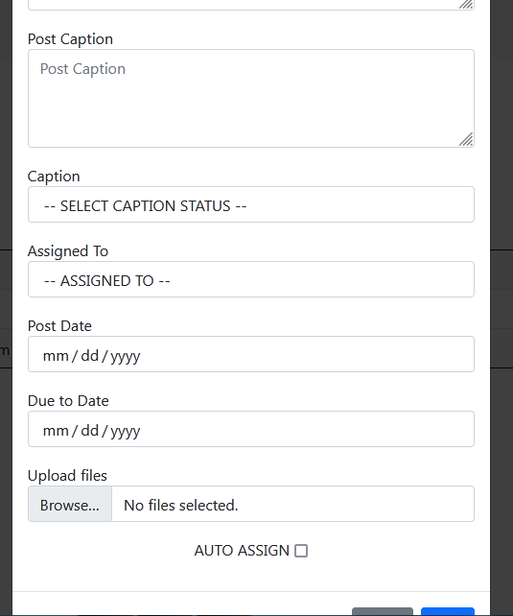

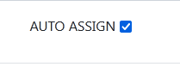

1. In calendar the page is overlapping into left corner kindly check this.

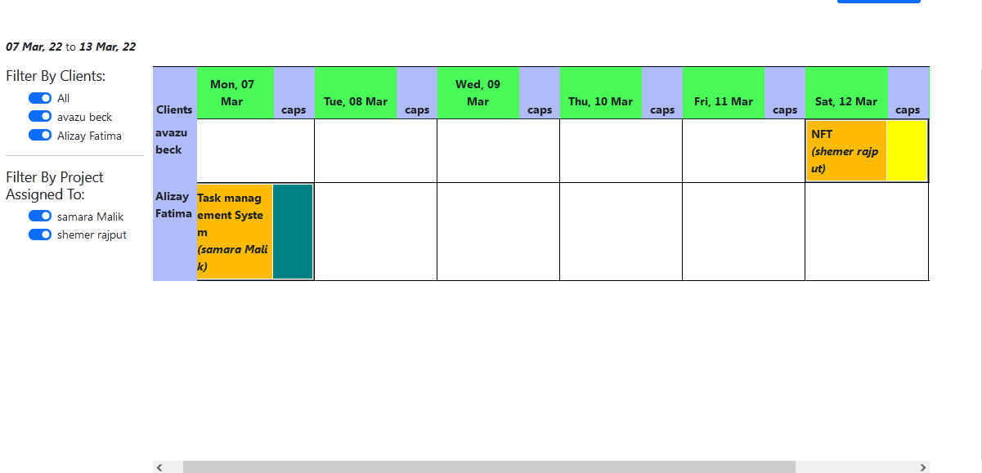

When moving forward to right corner

1. Kindly check the spelling of calendar. Replace a instead of e.

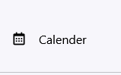

1. In settings the set colors line in below looking odd if any checkbox or any button are given so it’s looks good.

